PICTURES AND PACKINGLIST

IMAGE | N. |  | DESCRIPTION | BRAND / MODELL
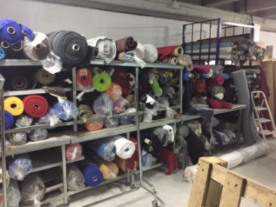 |  |  | Stock of fabric  About 1.000 kg
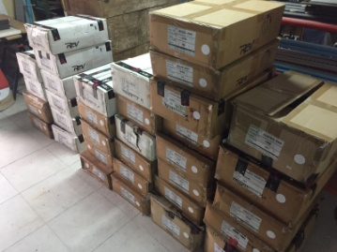  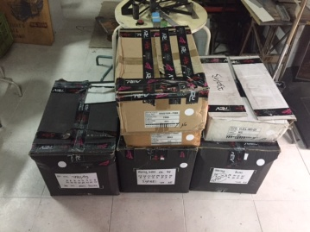  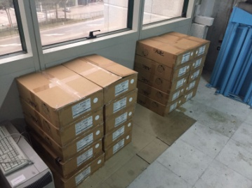 | 2423  circa |  | Woman jeans branded REV, various models and sizes  About 130 boxes – about 2.423 pieces | REV
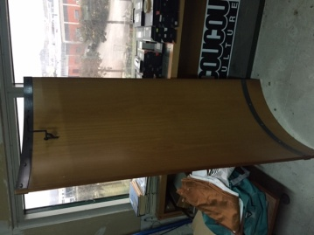 | 3 |  | Wood expositor
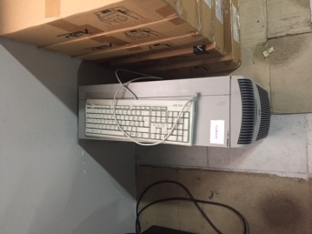 | 1 |  | PC complete with keyboard
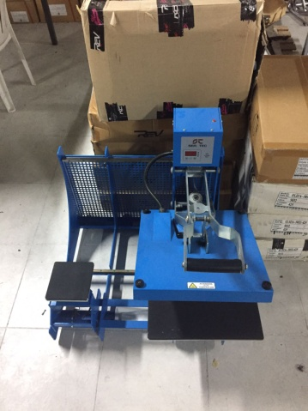 | 1 |  | Thermopress for transfer | SER. TEC. Mod. SPRESSMAN
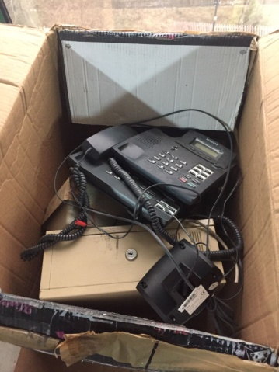 | 1 |  | Phones | SAMSUNG
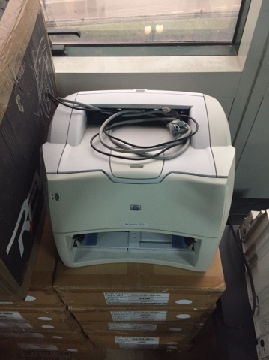 | 1 |  | Printer | HP LASERJET 1300N
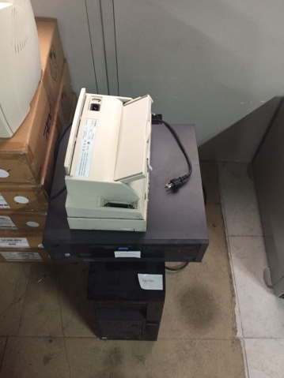 |  |  | SERVER | IBM NET VISTA
 |  |  | Printer | CANON MOD. K10140E
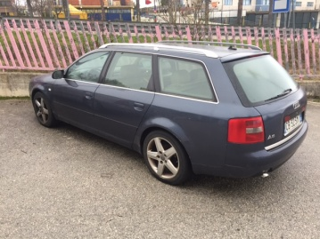 |  | AUDI A6  Battery down  YEAR 2003 – km 430.000 |  | CB323MT
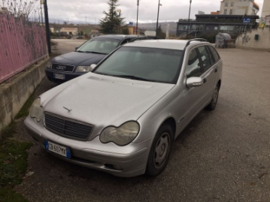 |  | MERCEDES C220 CD  Battery down  YEAR 2002 – km 275.000 |  | CB607MX

